**Practical No. 08**

**TITLE:** USE OF DATABASES USING ANDROID STUDIO

**AIM:** IMPLEMENT USE OF DATABASES USING ANDROID STUDIO

**APPARATUS:** ANDROID STUDIO

**THEORY:**

* **activity_main.xml**

<?xml version="1.0" encoding="utf-8"?>

<androidx.constraintlayout.widget.ConstraintLayout xmlns:android="http://schemas.android.com/apk/res/android"

xmlns:app="http://schemas.android.com/apk/res-auto"

xmlns:tools="http://schemas.android.com/tools"

android:layout_width="match_parent"

android:layout_height="match_parent"

android:orientation="vertical"

android:background="#ffffff"

tools:context=".MainActivity">

<ImageView

android:id="@+id/imageView10"

android:layout_width="0dp"

android:layout_height="0dp"

app:layout_constraintBottom_toBottomOf="parent"

app:layout_constraintEnd_toEndOf="parent"

app:layout_constraintStart_toStartOf="parent"

app:layout_constraintTop_toTopOf="parent"

app:srcCompat="@drawable/background_login" />

<ImageView

android:id="@+id/imageView4"

android:layout_width="wrap_content"

android:layout_height="wrap_content"

app:layout_constraintEnd_toEndOf="parent"

app:layout_constraintStart_toStartOf="parent"

app:layout_constraintTop_toTopOf="parent"

app:srcCompat="@drawable/top_background" />

app:layout_constraintStart_toStartOf="parent"

app:layout_constraintTop_toTopOf="parent"

app:srcCompat="@drawable/top_background" />

<ScrollView

android:layout_width="match_parent"

android:layout_height="match_parent">

<LinearLayout

android:layout_width="match_parent"

android:layout_height="wrap_content"

android:orientation="vertical" >

<TextView

android:id="@+id/textView"

android:layout_width="match_parent"

android:layout_height="wrap_content"

android:text="Create\nAccount"

android:textColor="#603a91"

android:textSize="40sp"

android:layout_marginBottom="35dp"

android:textStyle="bold"

android:layout_marginStart="32dp"

android:layout_marginTop="80dp"/>

<EditText

android:id="@+id/fullname"

android:layout_width="match_parent"

android:layout_height="50dp"

android:ems="10"

android:inputType="textPersonName"

android:drawableStart="@drawable/name"

android:textColorHint="#603a91"

android:textColor="#603a91"

android:background="@drawable/edittext_background"

android:hint="Name"

android:layout_marginStart="32dp"

android:layout_marginTop="32dp"

android:layout_marginEnd="32dp"

android:padding="8dp"

android:drawablePadding="16dp"/>

**Conclusion:** Thus we implemented the installation o

<EditText

android:id="@+id/number"

android:layout_width="match_parent"

android:layout_height="50dp"

android:layout_marginStart="32dp"

android:layout_marginTop="32dp"

android:layout_marginEnd="32dp"

android:textColor="#603a91"

android:background="@drawable/edittext_background"

android:drawableStart="@drawable/baseline_mobile_friendly_24"

android:drawablePadding="16dp"

android:ems="10"

android:hint="Mobile Number"

android:inputType="numberDecimal"

android:maxLength="11"

android:padding="8dp"

android:textColorHint="#603a91" />

<EditText

android:id="@+id/email"

android:layout_width="match_parent"

android:layout_height="50dp"

android:ems="10"

android:inputType="textPersonName"

android:drawableStart="@drawable/email"

android:textColorHint="#603a91"

android:textColor="#603a91"

android:background="@drawable/edittext_background"

android:hint="Email"

android:layout_marginStart="32dp"

android:layout_marginTop="32dp"

android:layout_marginEnd="32dp"

android:padding="8dp"

android:drawablePadding="16dp"/>

<EditText

android:id="@+id/password"

android:layout_width="match_parent"

android:layout_height="50dp"

android:ems="10"

android:inputType="textPassword"

android:drawableStart="@drawable/password"

android:textColorHint="#603a91"

android:textColor="#603a91"

android:background="@drawable/edittext_background"

android:hint="Password"

android:layout_marginStart="32dp"

android:layout_marginTop="32dp"

android:layout_marginEnd="32dp"

android:padding="8dp"

android:drawablePadding="16dp"/>

<ImageView

android:id="@+id/signup"

android:layout_gravity="end"

android:layout_marginTop="16dp"

android:layout_width="wrap_content"

android:layout_height="wrap_content"

app:srcCompat="@drawable/btn_login" />

<TextView

android:id="@+id/gotologinactivity"

android:layout_width="wrap_content"

android:layout_height="wrap_content"

android:text="Already have an account? Sign in"

android:textColor="#603a91"

android:textStyle="bold"

android:textSize="17sp"

android:layout_gravity="center"/>

</LinearLayout>

</ScrollView>

</androidx.constraintlayout.widget.ConstraintLayout>

* **MainActivity.java**

package com.example.useofdatabase;

import androidx.annotation.NonNull;

import androidx.appcompat.app.AppCompatActivity;

import android.app.Activity;

import android.app.ProgressDialog;

import android.content.Intent;

import android.os.Bundle;

import android.view.View;

import android.widget.Toast;

import com.example.useofdatabase.databinding.ActivityLoginBinding;

import com.example.useofdatabase.databinding.ActivityMainBinding;

import com.google.android.gms.tasks.OnFailureListener;

import com.google.android.gms.tasks.OnSuccessListener;

import com.google.firebase.auth.AuthResult;

import com.google.firebase.auth.FirebaseAuth;

import com.google.firebase.firestore.FirebaseFirestore;

import com.google.firebase.firestore.auth.User;

public class MainActivity extends AppCompatActivity {

ActivityMainBinding binding;

FirebaseAuth firebaseAuth;

ProgressDialog progressDialog;

FirebaseFirestore firebaseFirestore;

@Override

protected void onCreate(Bundle savedInstanceState) {

super.onCreate(savedInstanceState);

binding=ActivityMainBinding.inflate(getLayoutInflater());

firebaseAuth=FirebaseAuth.getInstance();

setContentView(binding.getRoot());

progressDialog=new ProgressDialog(this);

firebaseFirestore=FirebaseFirestore.getInstance();

binding.signup.setOnClickListener(new View.OnClickListener() {

@Override

public void onClick(View v) {

String name= binding.fullname.getText().toString();

String number= binding.number.getText().toString();

String email= binding.email.getText().toString().trim();

String password= binding.password.getText().toString();

progressDialog.show(); firebaseAuth.createUserWithEmailAndPassword(email,password)

.addOnSuccessListener(new OnSuccessListener<AuthResult>() {

@Override

public void onSuccess(AuthResult authResult) {

startActivity(new Intent(MainActivity.this,LoginActivity.class));

progressDialog.cancel(); firebaseFirestore.collection("User")

.document(FirebaseAuth.getInstance().getUid()).set(new UserModel(name,number,email));

}

})

.addOnFailureListener(new OnFailureListener() {

@Override

public void onFailure(@NonNull Exception e) {

Toast.makeText(MainActivity.this, e.getMessage(), Toast.LENGTH_SHORT).show();

progressDialog.cancel();

}

});

}

});

binding.gotologinactivity.setOnClickListener(new View.OnClickListener() {

@Override

public void onClick(View v) {

startActivity(new Intent(MainActivity.this, LoginActivity.class));

}

});

}

@Override

public void onBackPressed() {

Intent a = new Intent(Intent.ACTION_MAIN);

a.addCategory(Intent.CATEGORY_HOME);

a.setFlags(Intent.FLAG_ACTIVITY_NO_HISTORY);

startActivity(a);

}

}

* **Output on Emulator –**

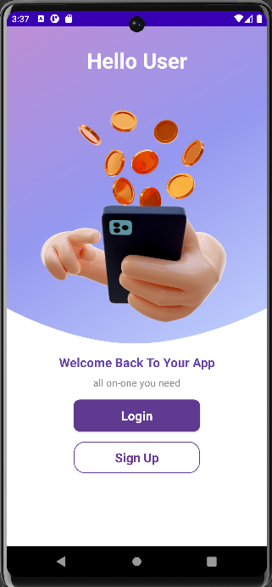

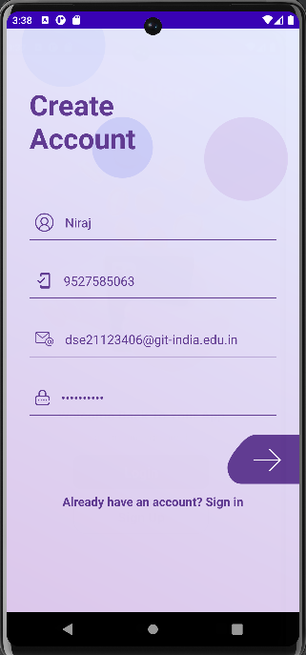

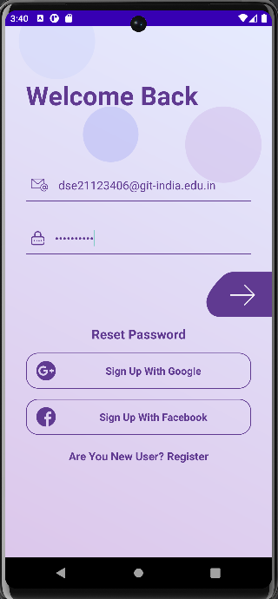



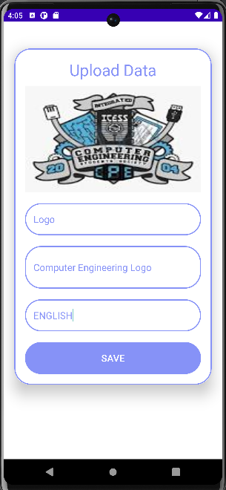

**Conclusion:** Thus we studied the implementation of use of databases in Android Studio.